Terraform Assessment – 3

**PRE- REQUESITE**

**Azure CLI:** [Install the Azure CLI for Windows | Microsoft Learn](https://learn.microsoft.com/en-us/cli/azure/install-azure-cli-windows?tabs=azure-cli)

**Aws CLI:** [Install Aws CLI for Windows](https://awscli.amazonaws.com/AWSCLIV2.msi)

**Extension in VS Code:** Hashi Corp Terraform

**GitHub:** [Vishal-Bharath-Kumar (github.com)](https://github.com/Vishal-Bharath-Kumar)

# Azure Blob Storage

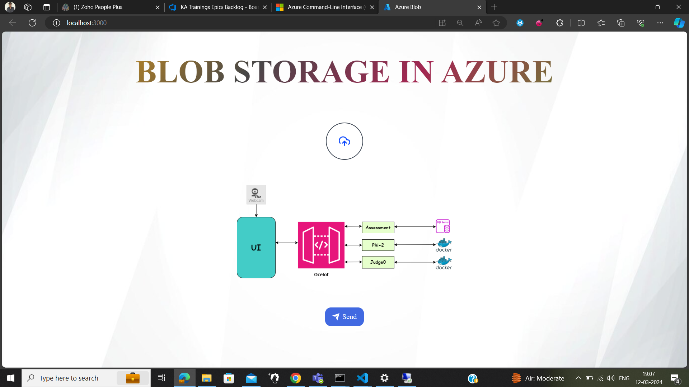

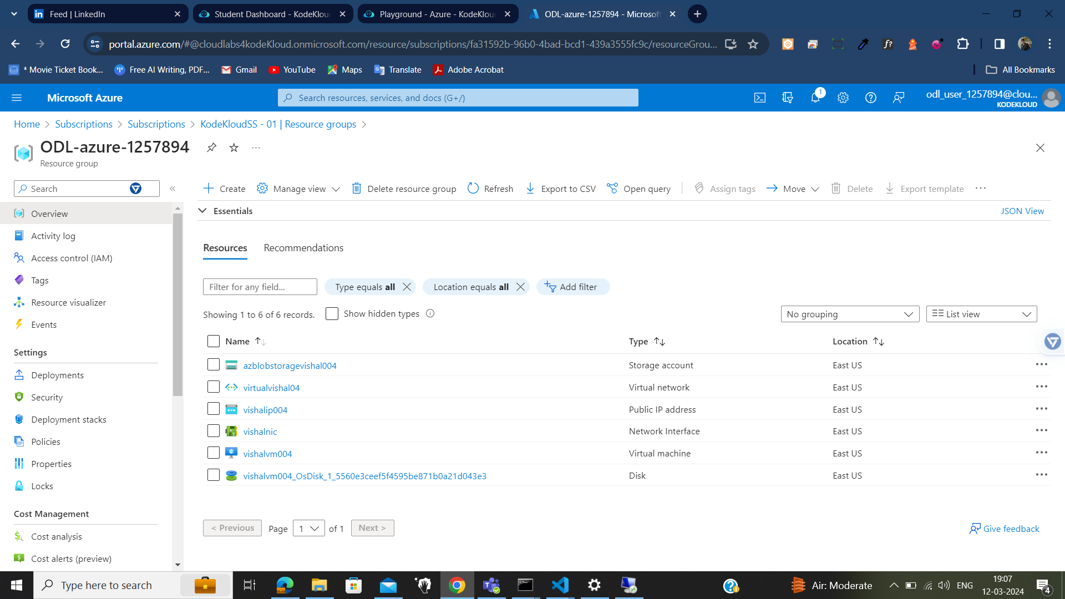

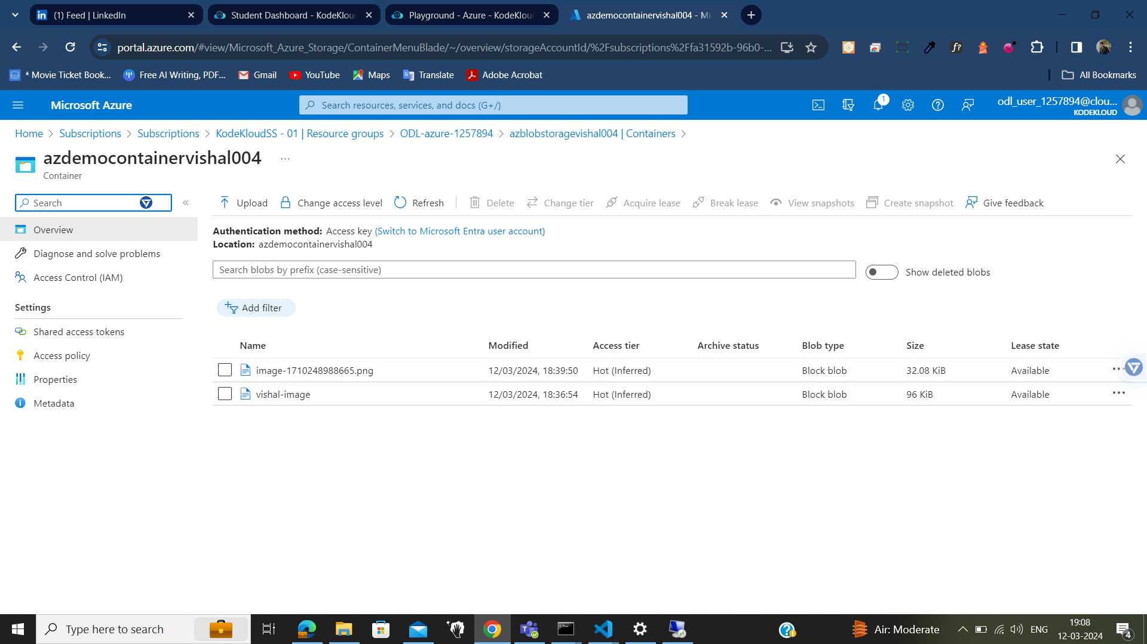

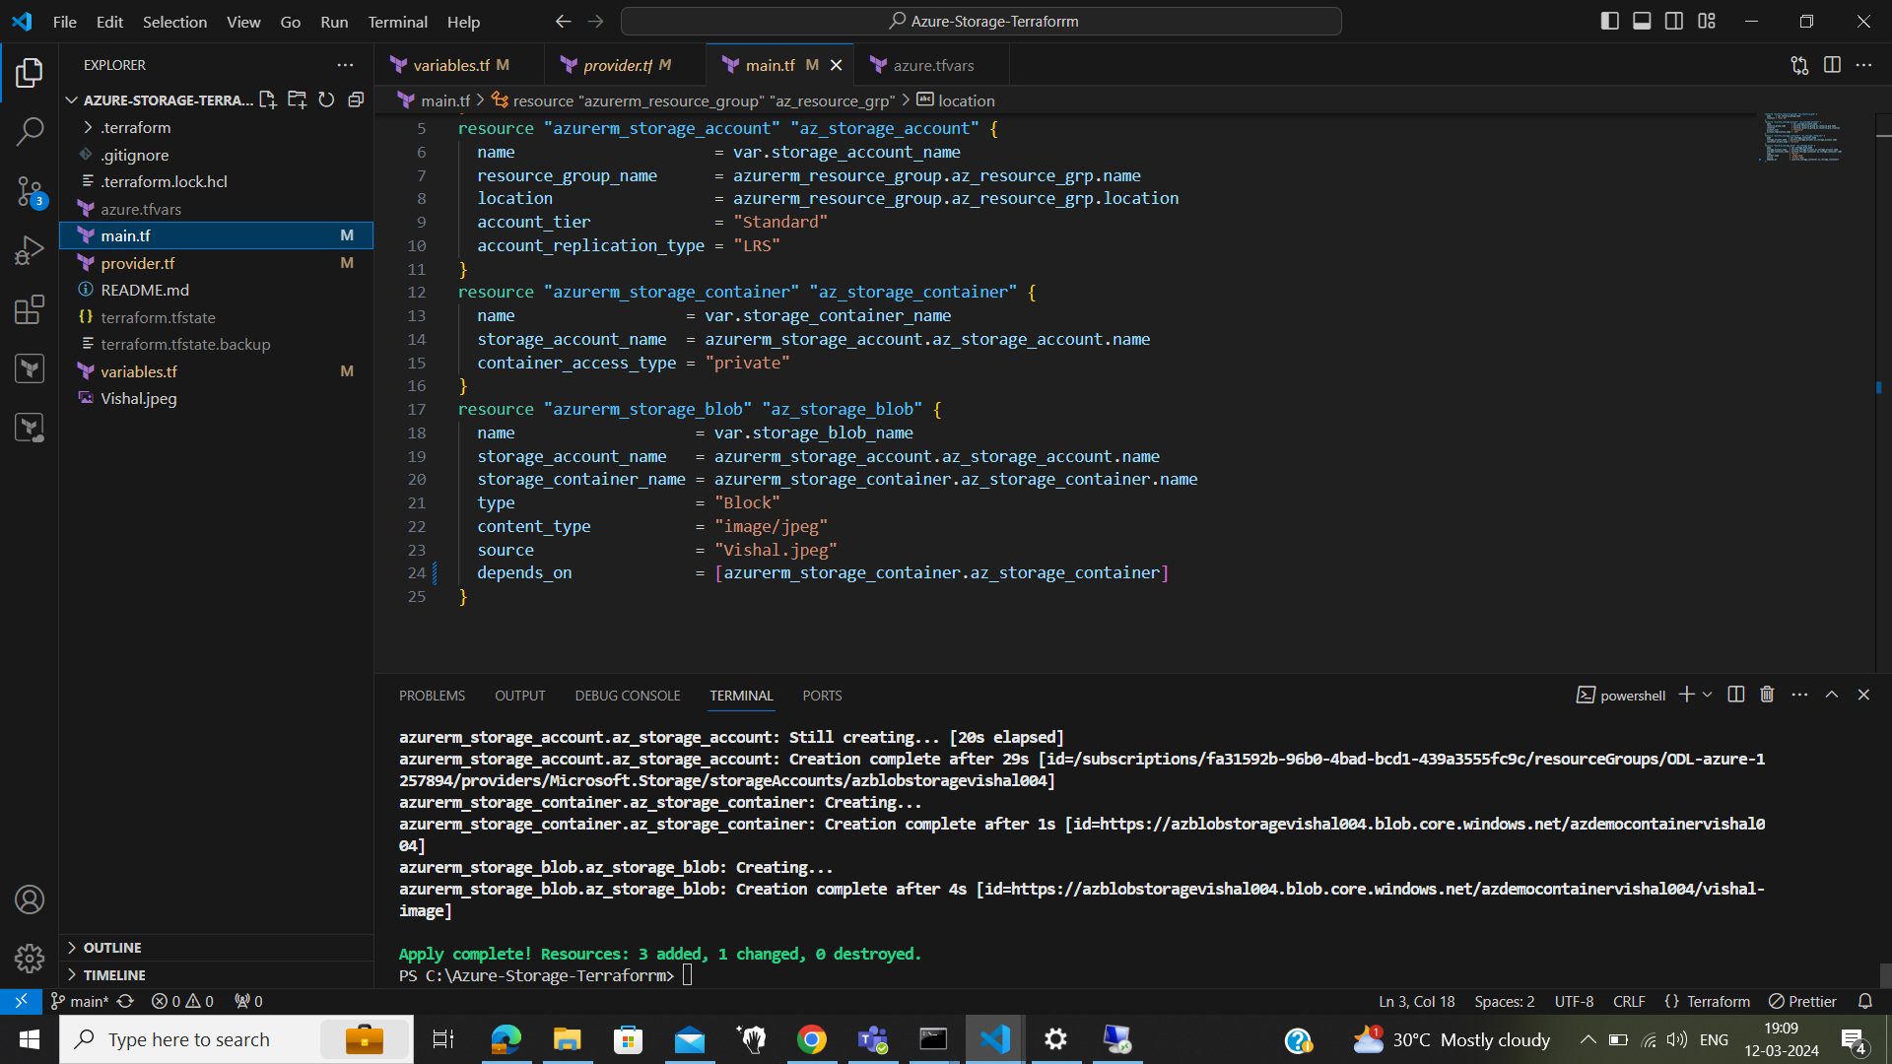

# Azure Virtual Machine



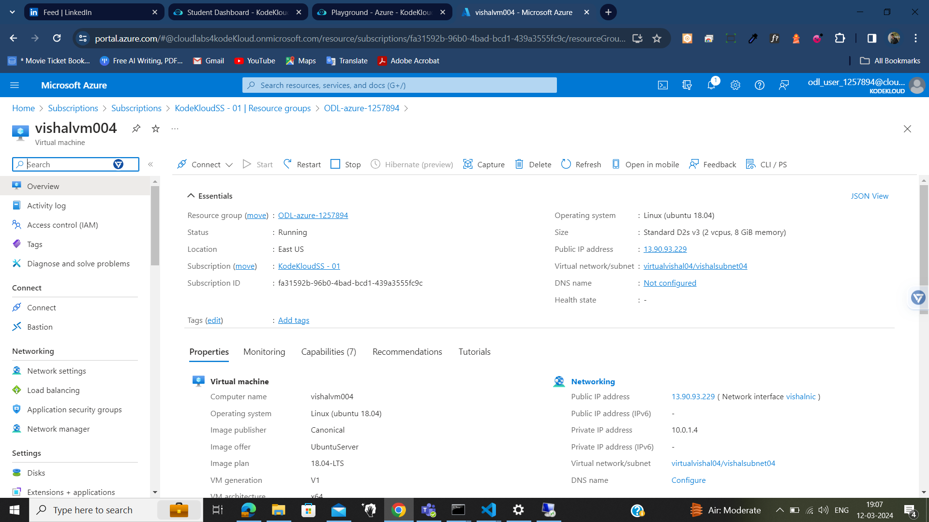

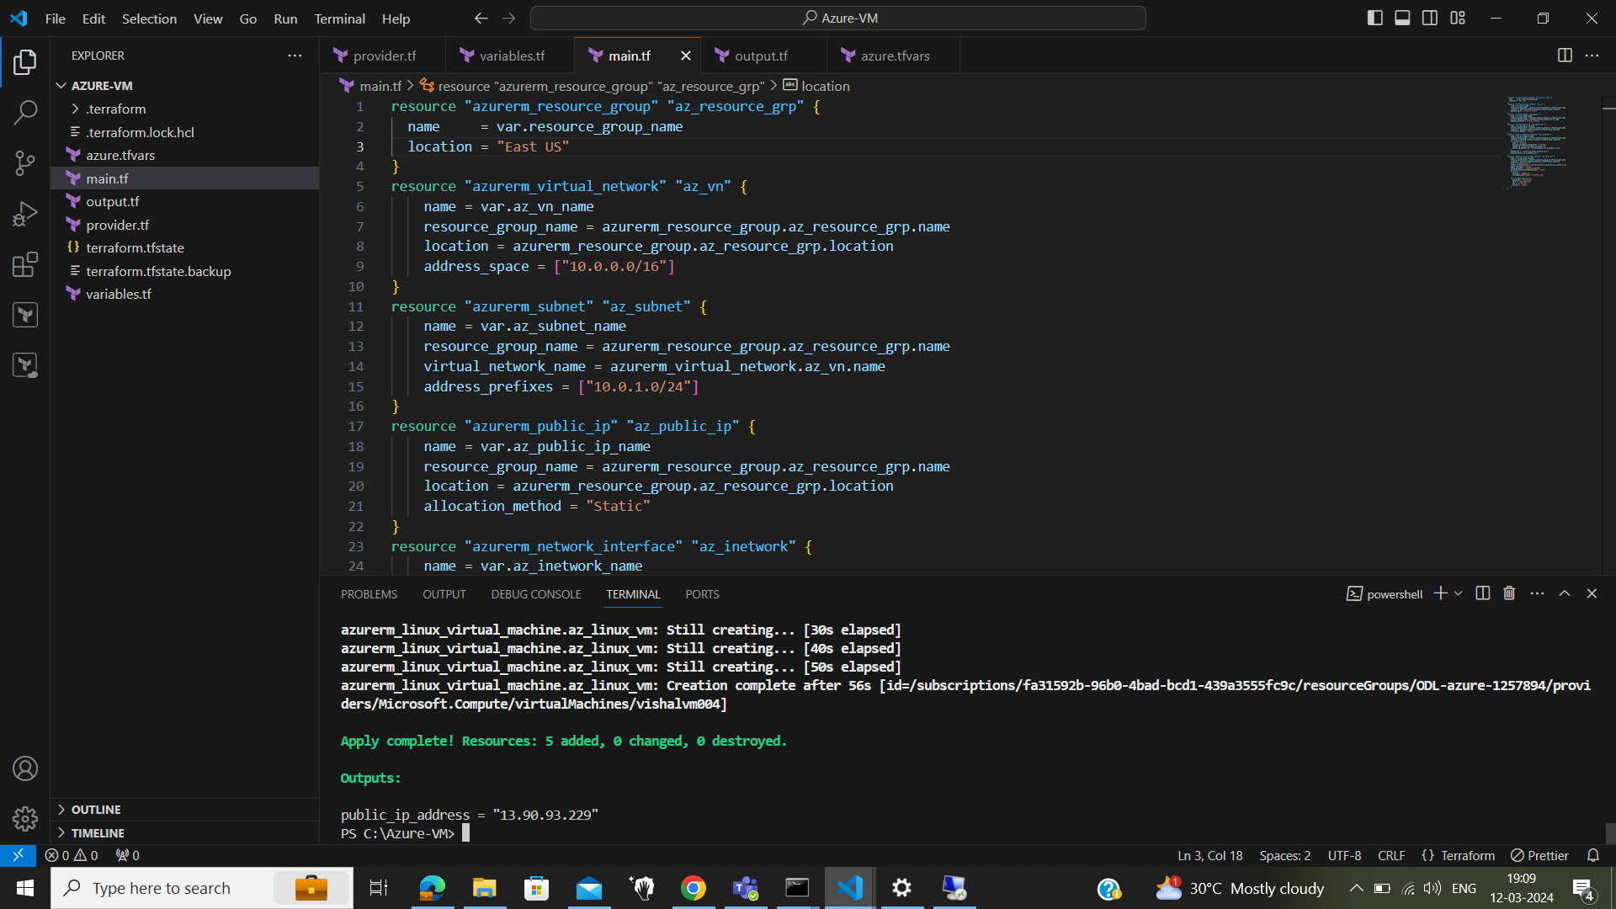

# Azure App Service

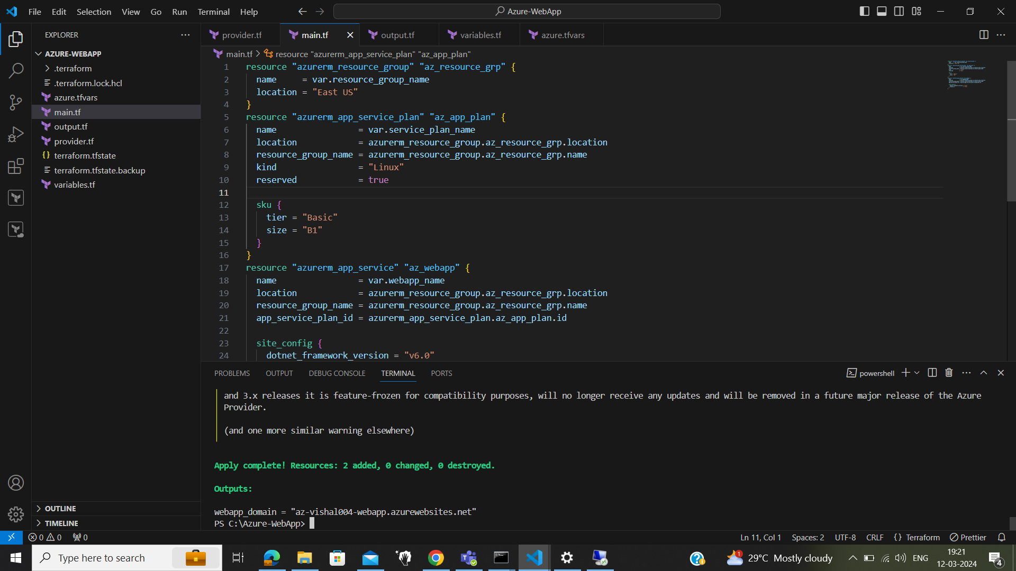

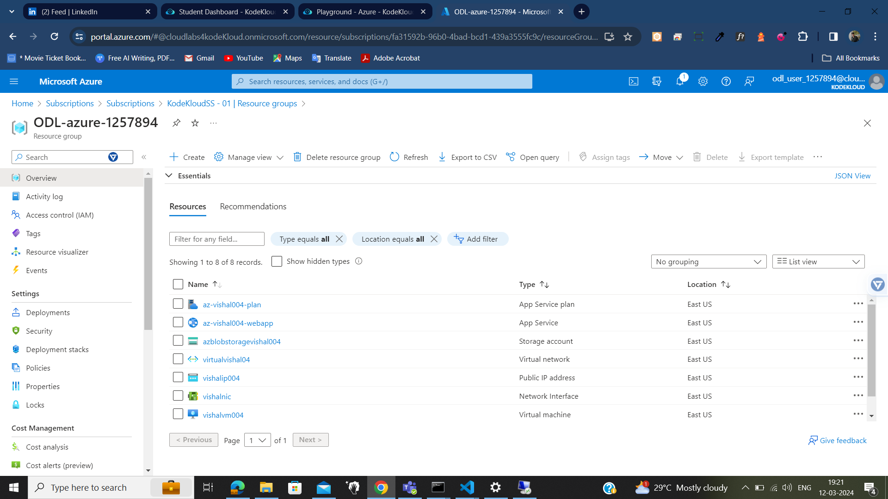

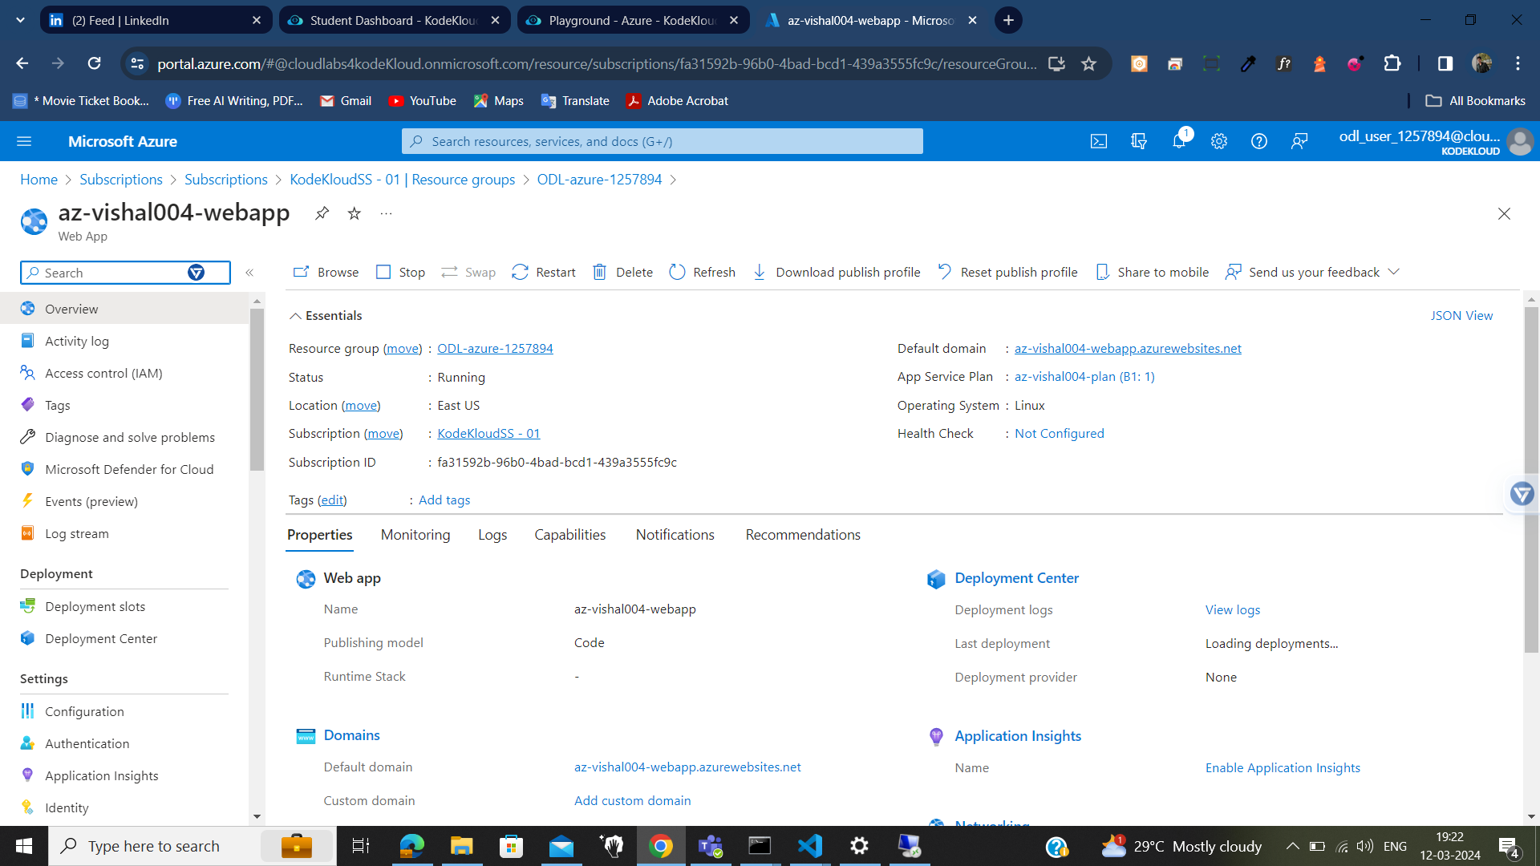

# AWS S3 Static web hosting

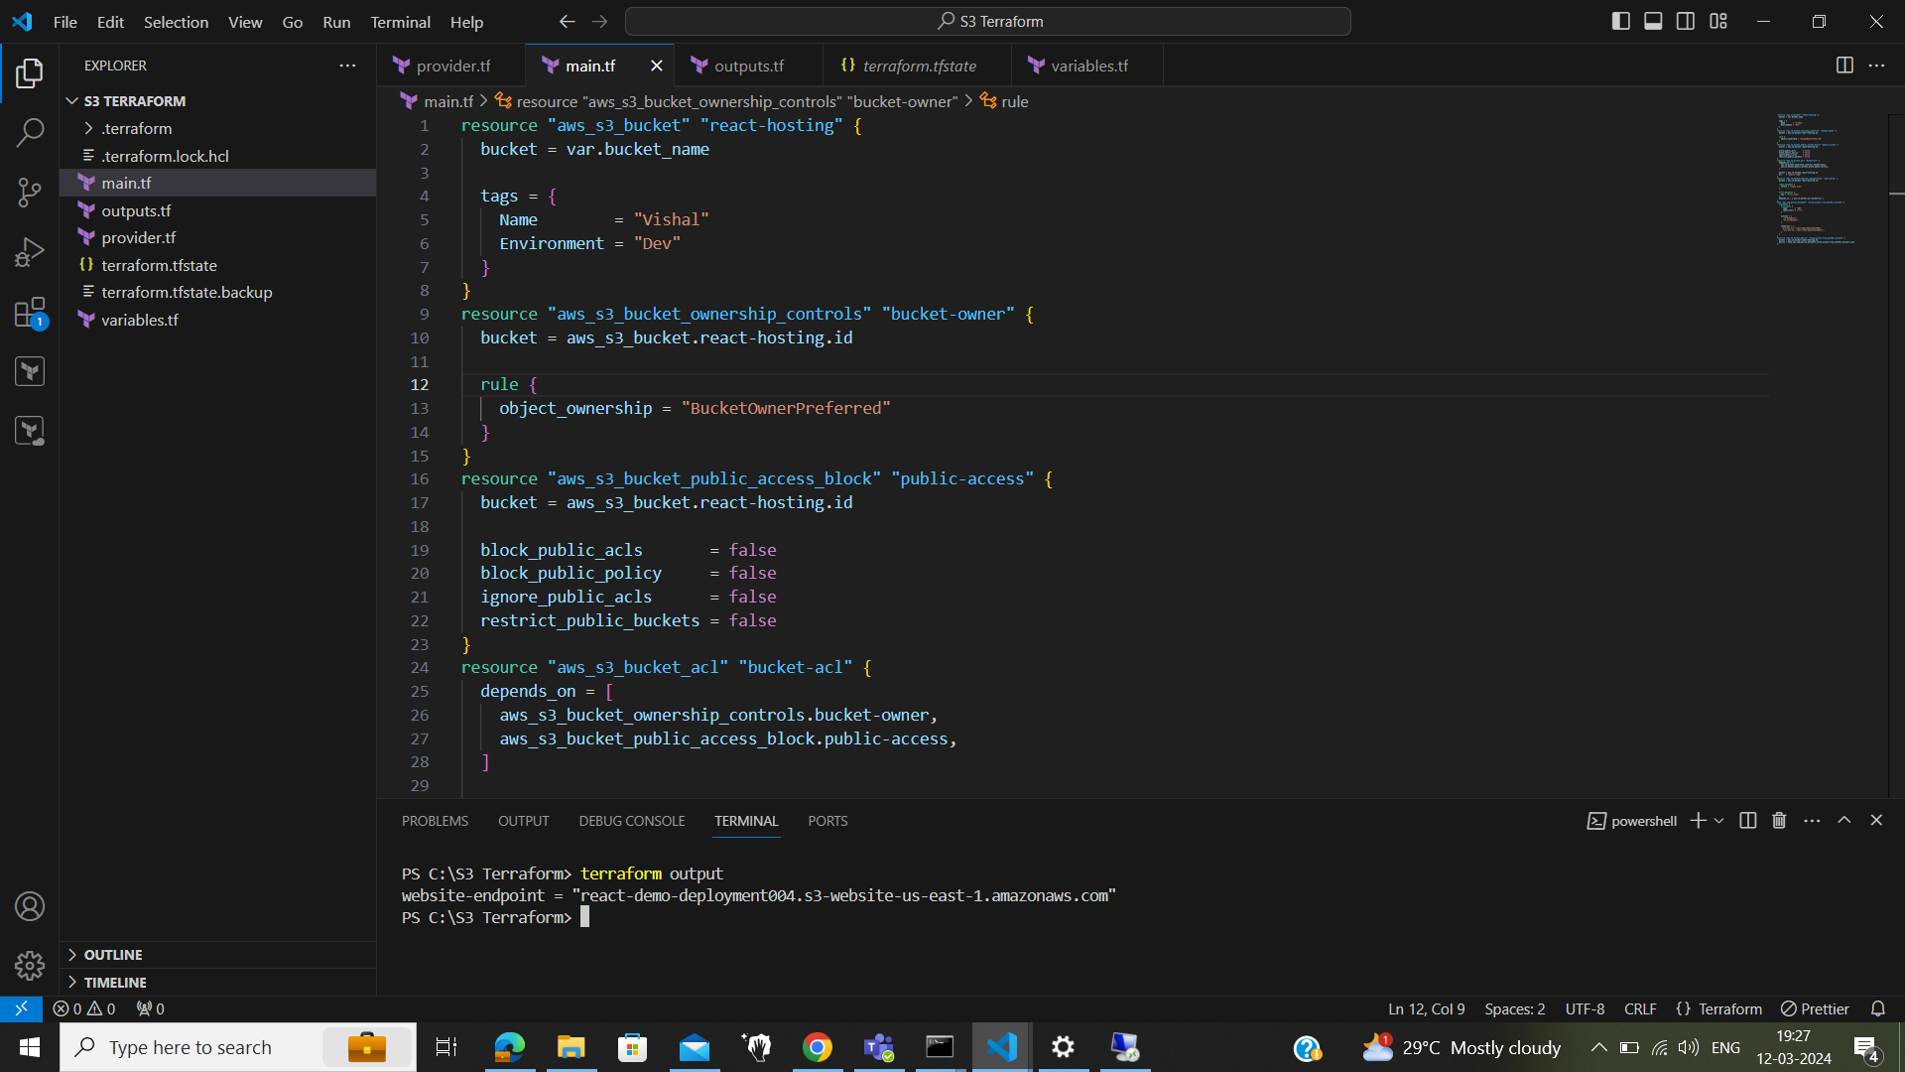

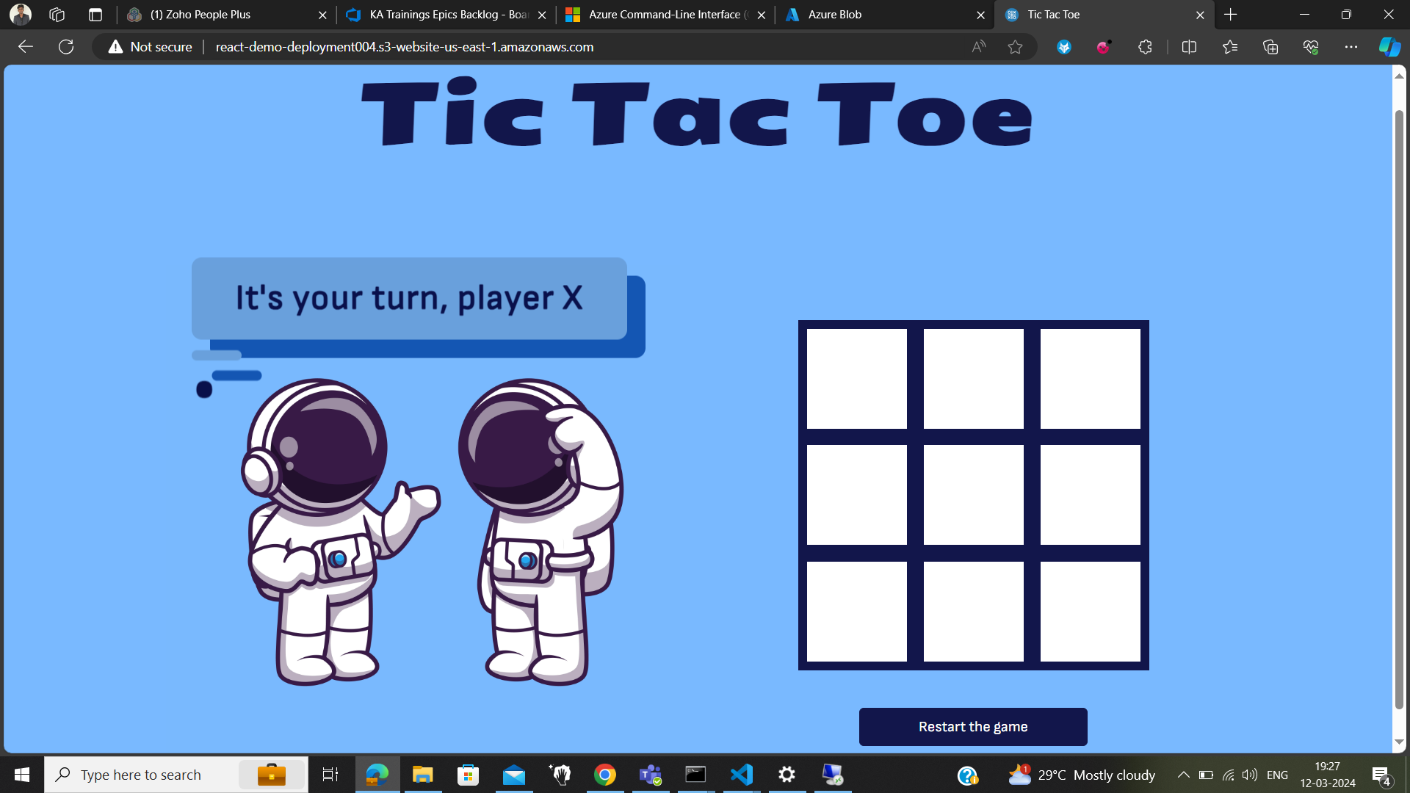

# Azure SQL Server

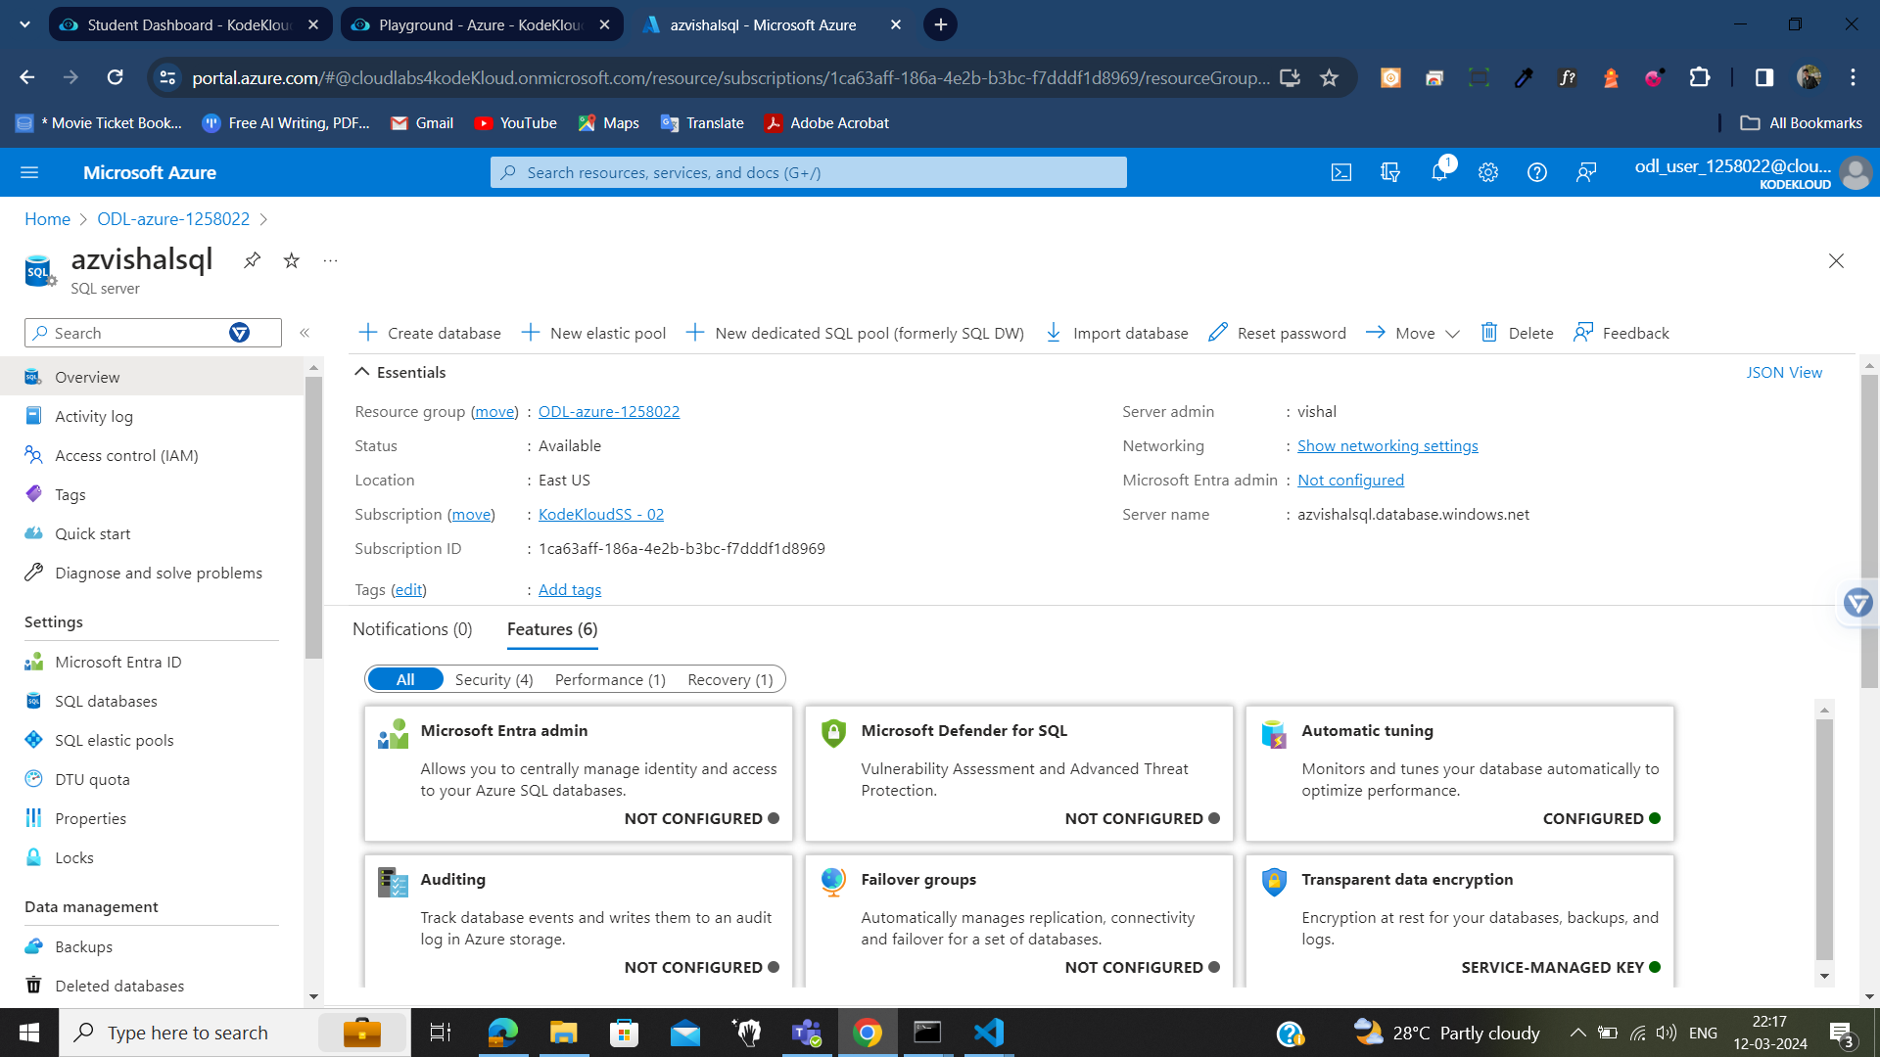

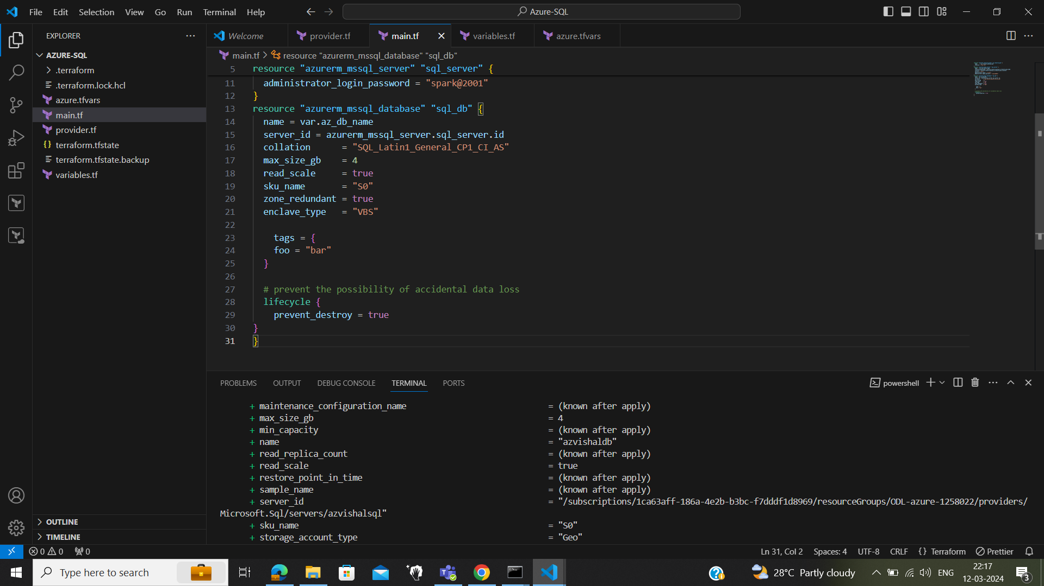

# Azure Key Vault

